Infrastructure as code, testing and deploying changes

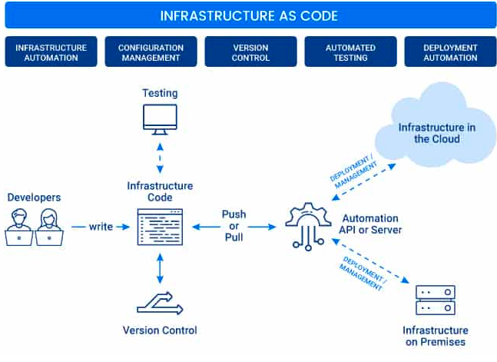

We can use various tools for the above representation

Version Control: GIT

Artifactory: jFrog

CI/CD Tool: Jenkins

Containerization: Docker

Orchestration Tool: Rancher/K8S